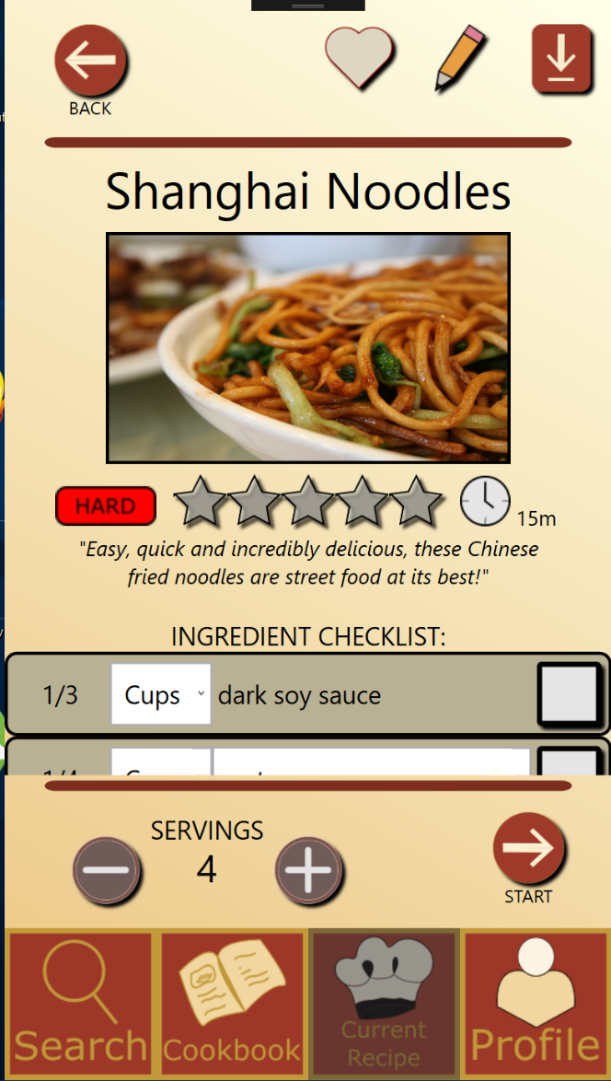

1. ) Recipe Profile Screen

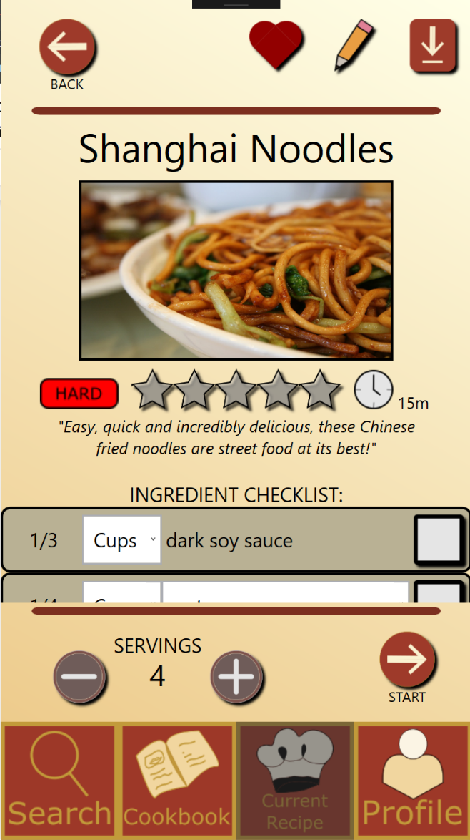

2.) Recipe Profile Screen, Favourited

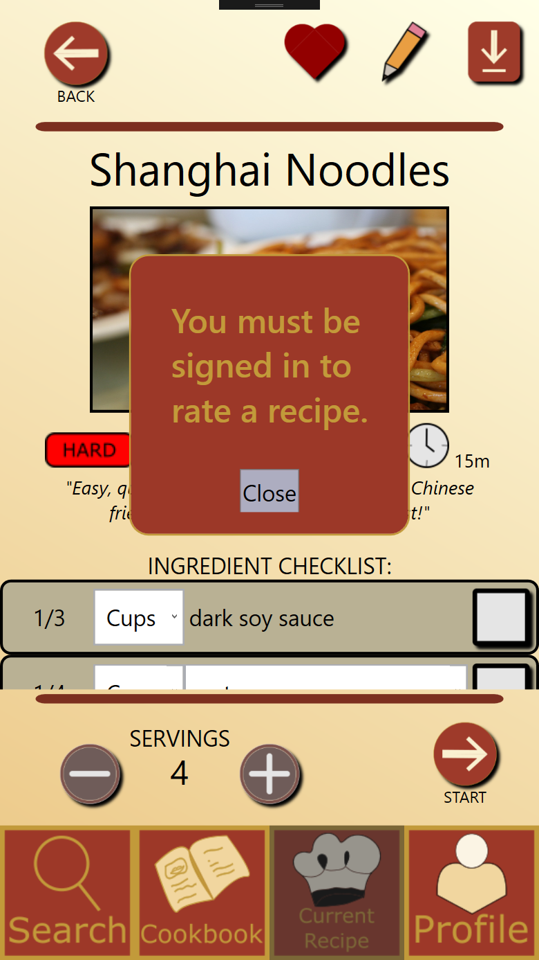

3.) Recipe Profile Screen, rate recipe, no login

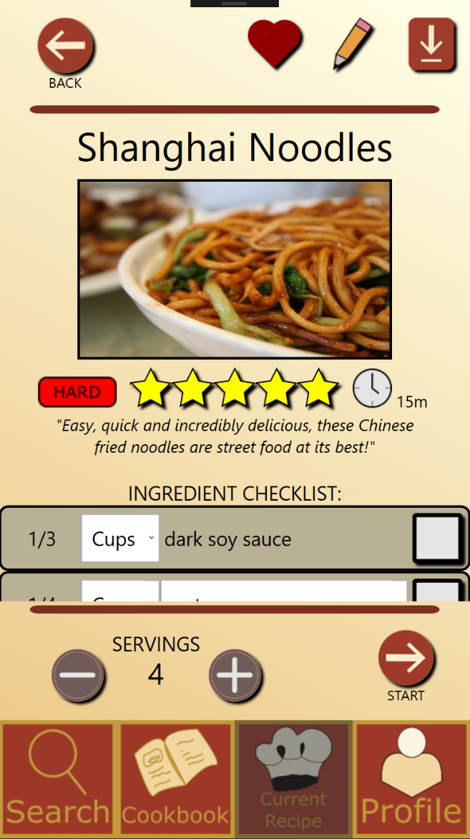

4.) Recipe Profile Screen, rate recipe, logged in

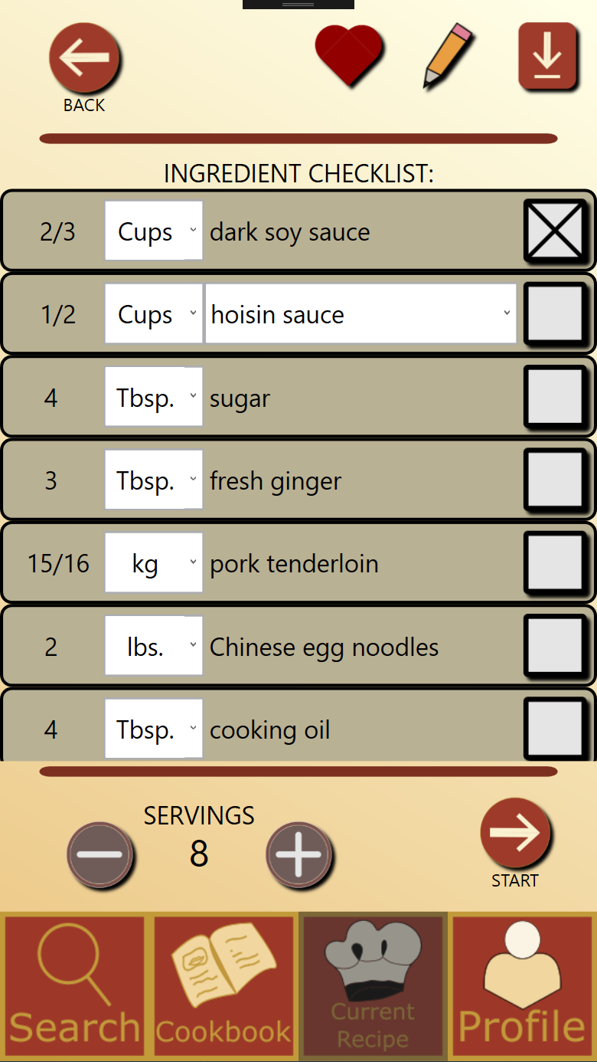

5.) Recipe Profile screen, change serving size

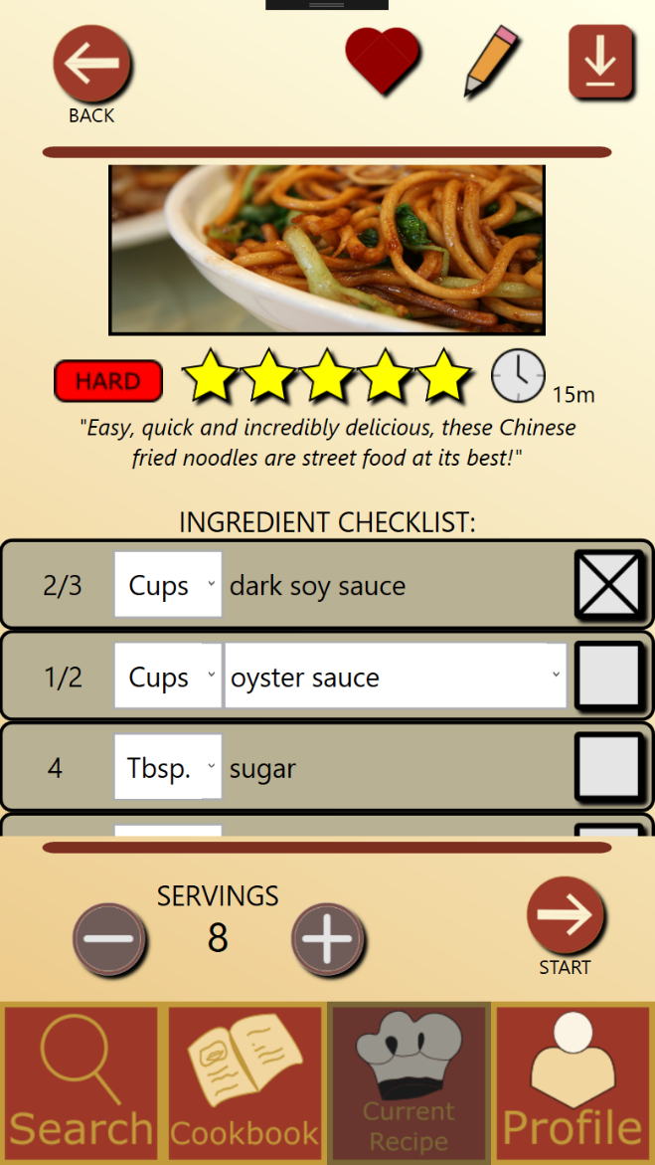

6.) Recipe Profile Screen, ingredient checklist

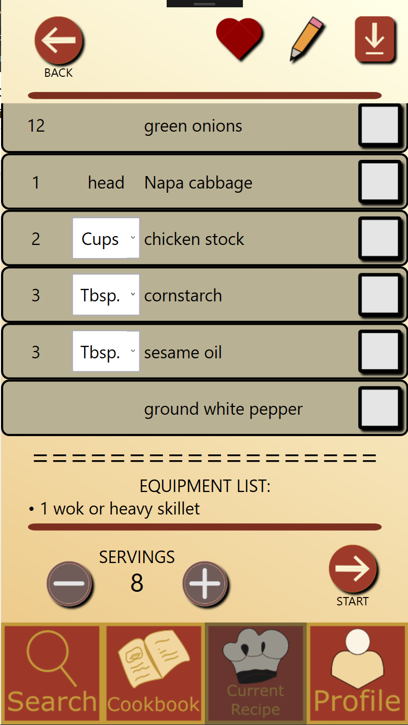

7.) Recipe Profile Screen, scroll area

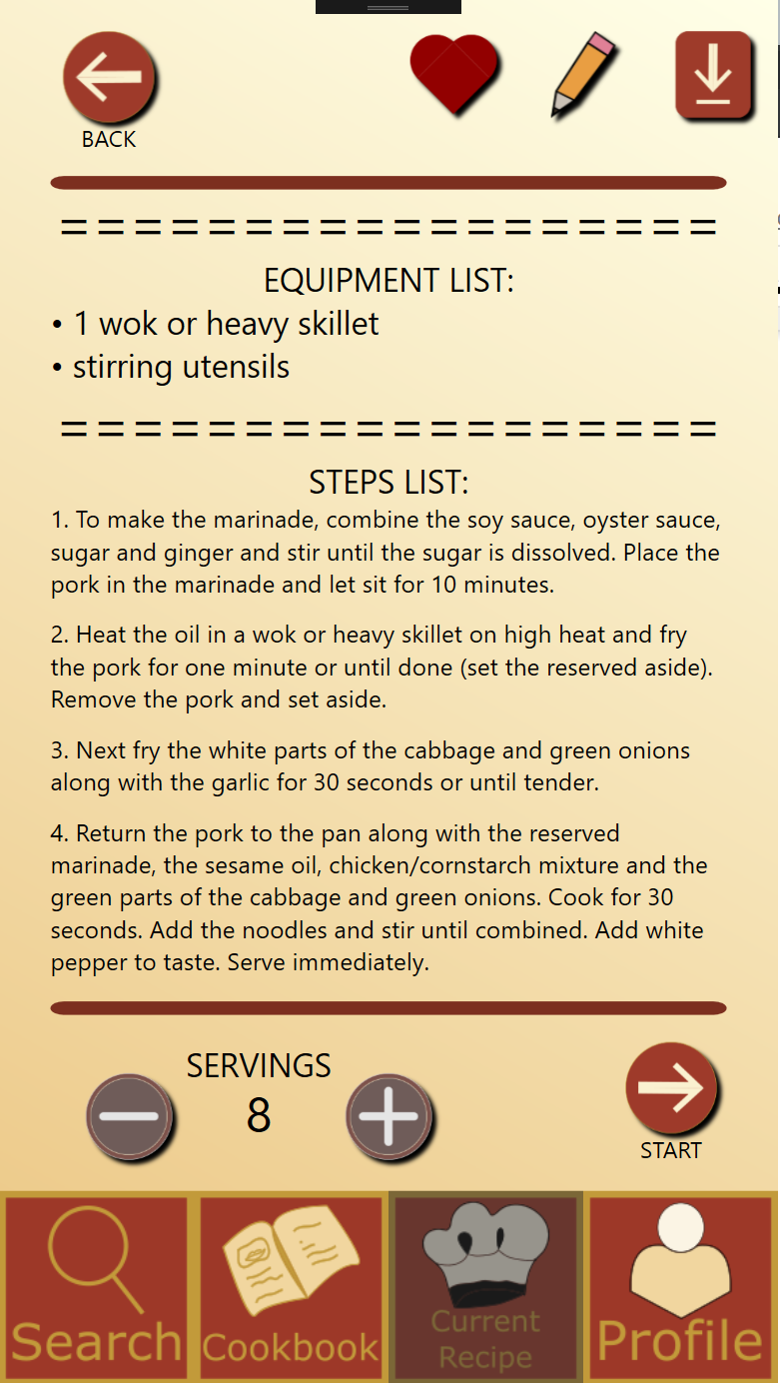

8.) Recipe Profile Screen, scroll area cont’d

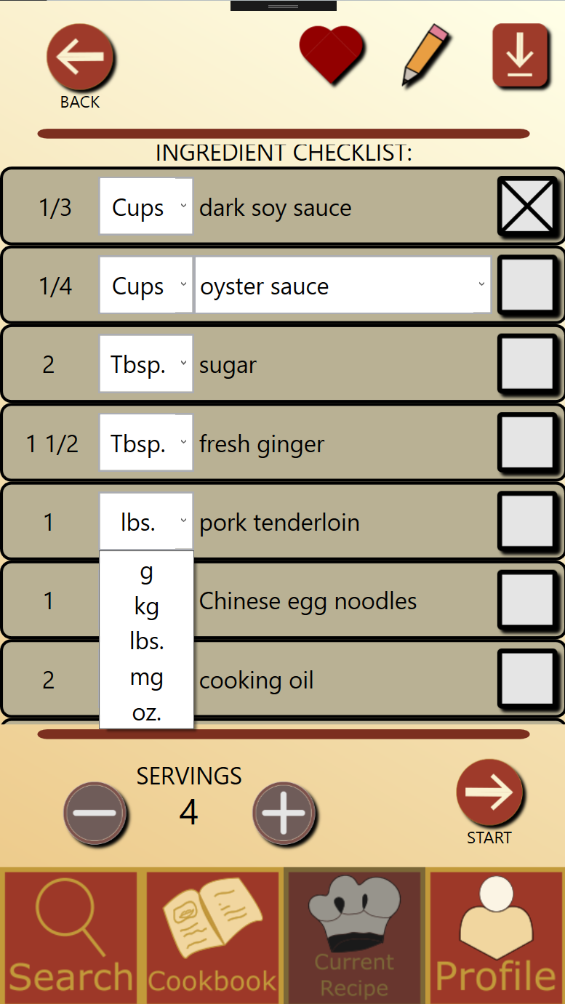

9.) Recipe Profile Screen, unit conversion

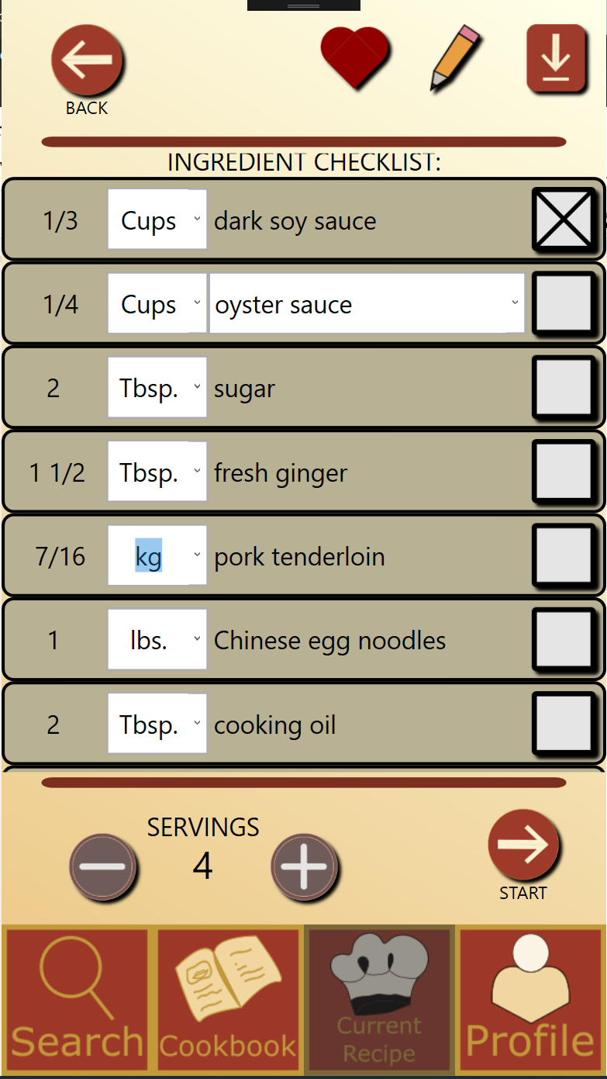

10.) Recipe Profile Screen, unit conversion cont’d

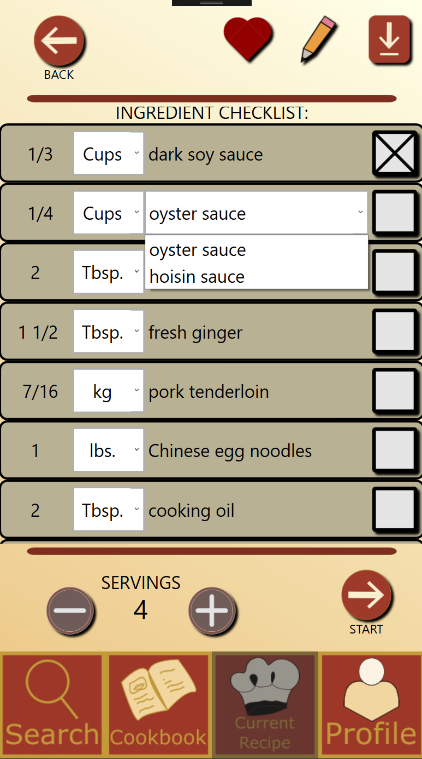

11.) Recipe Profile Screen, substitution

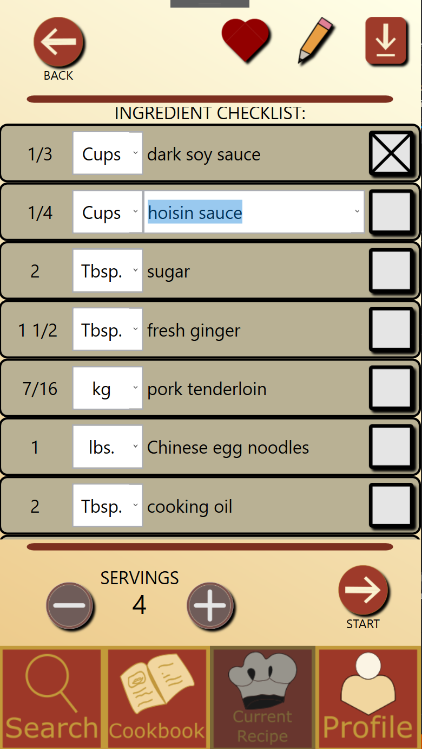

12.) Recipe Profile Screen, substitution cont’d

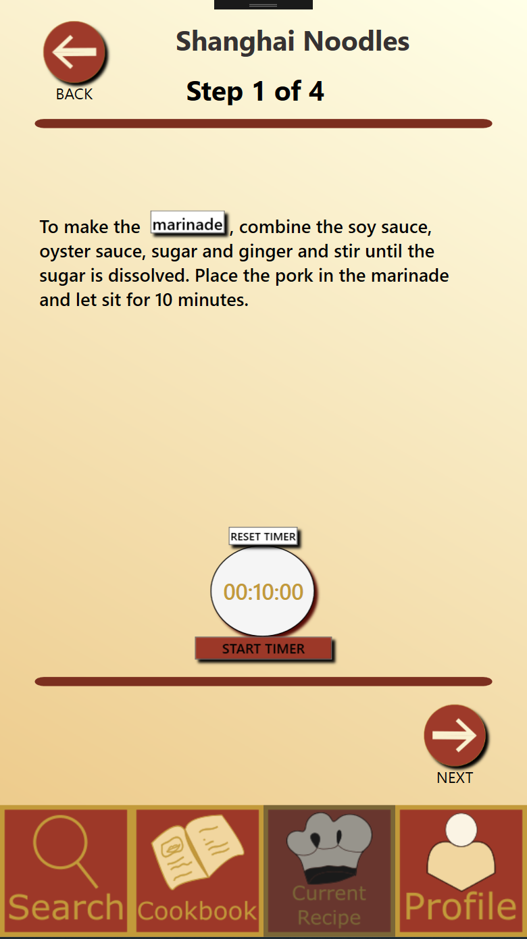

13.) Recipe Step by Step Screen

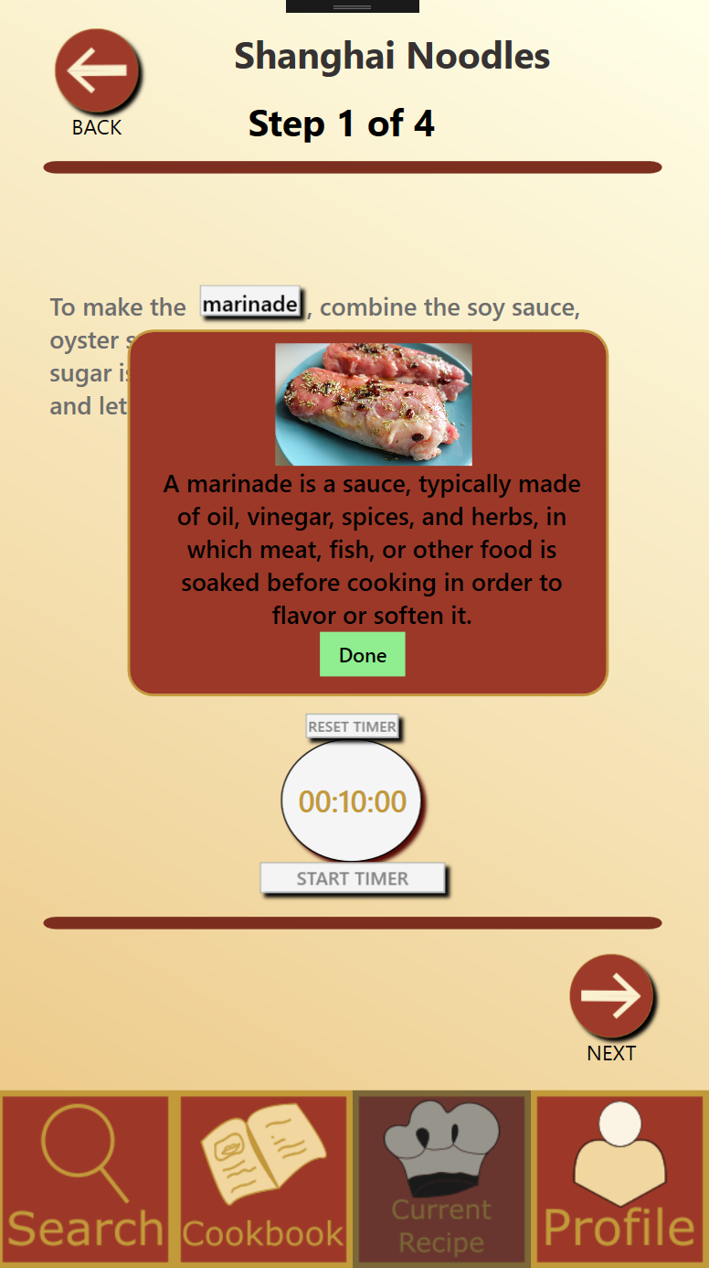

14.) Recipe step by step, Term look up pop up screen

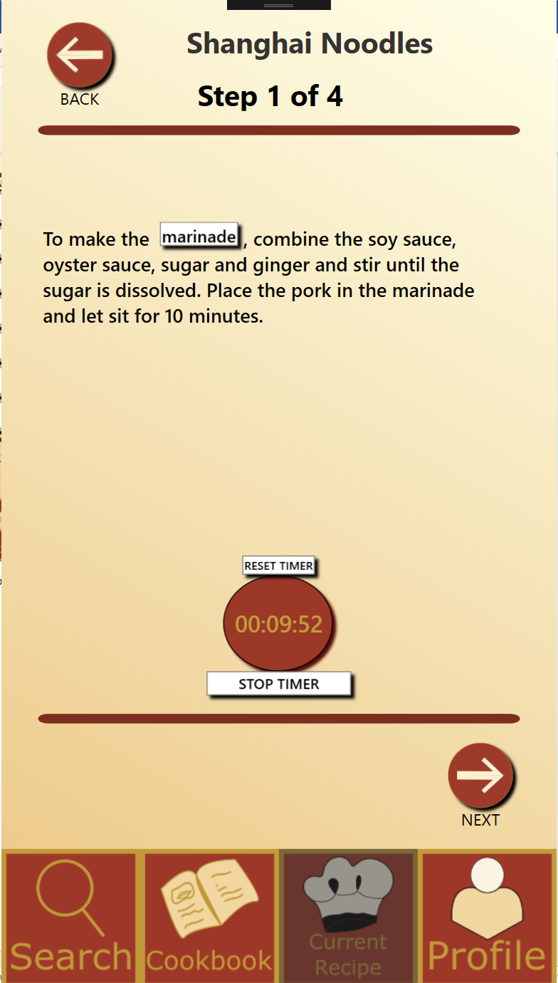

15.) Recipe Step by Step, timer

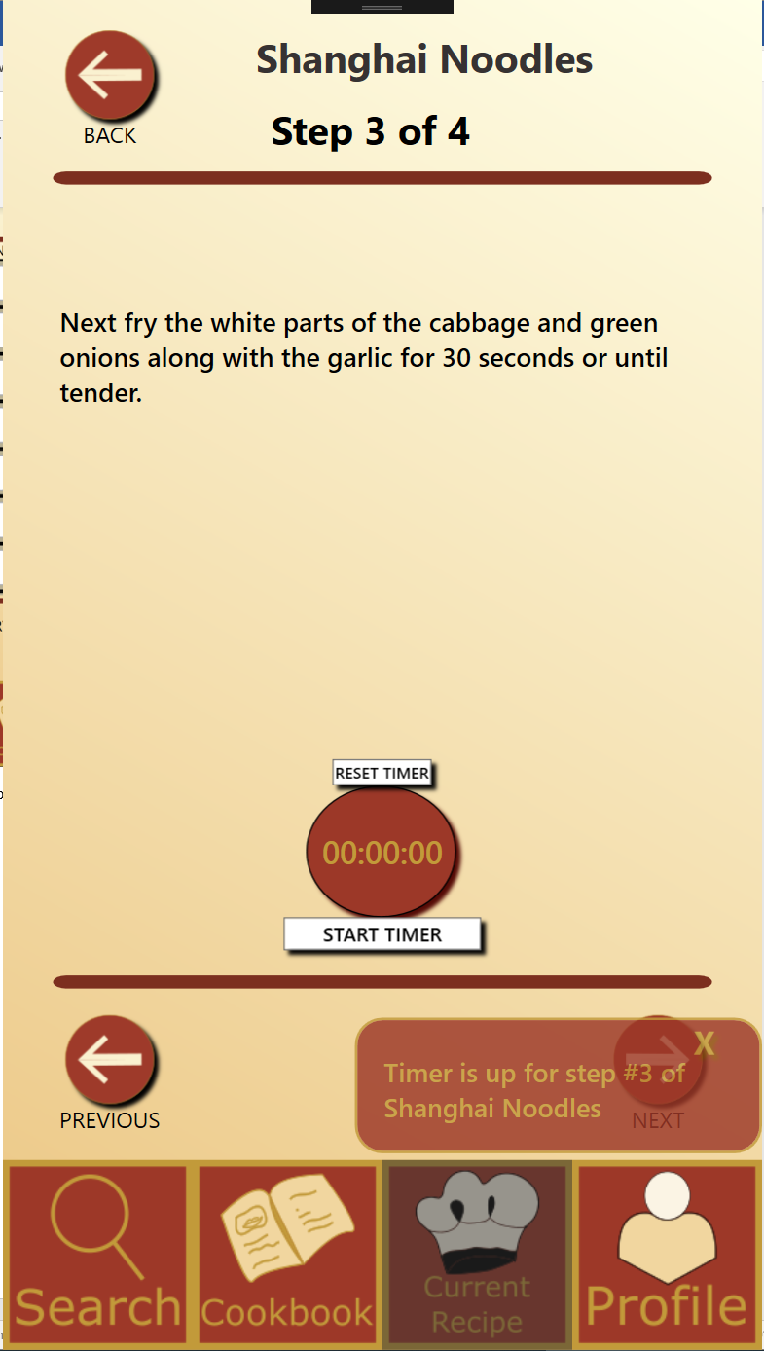

16.) Recipe Step by Step, timer cont’d

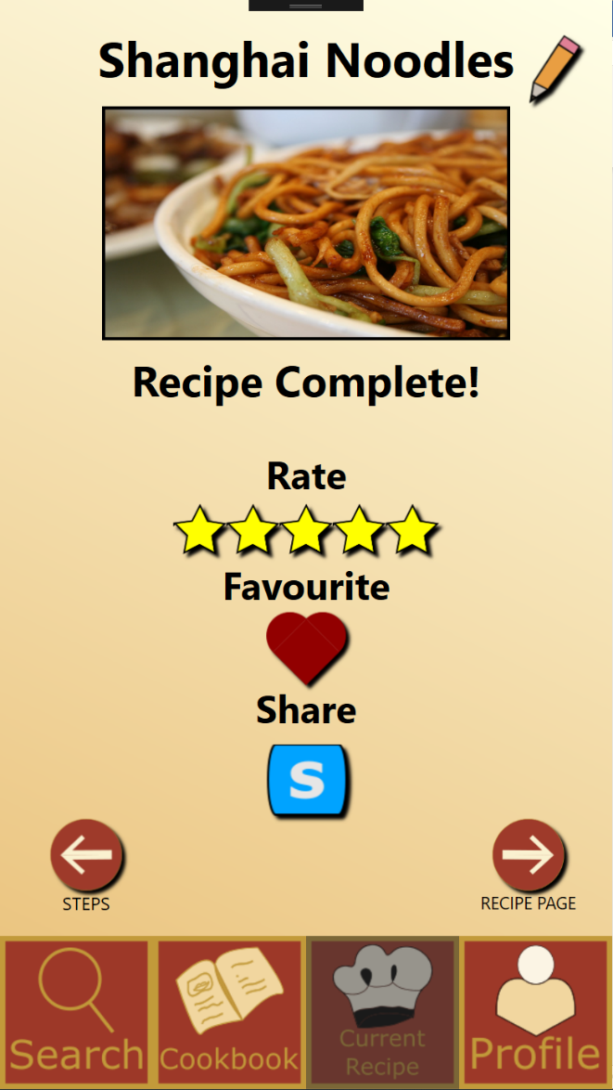

17.) Recipe Completion page

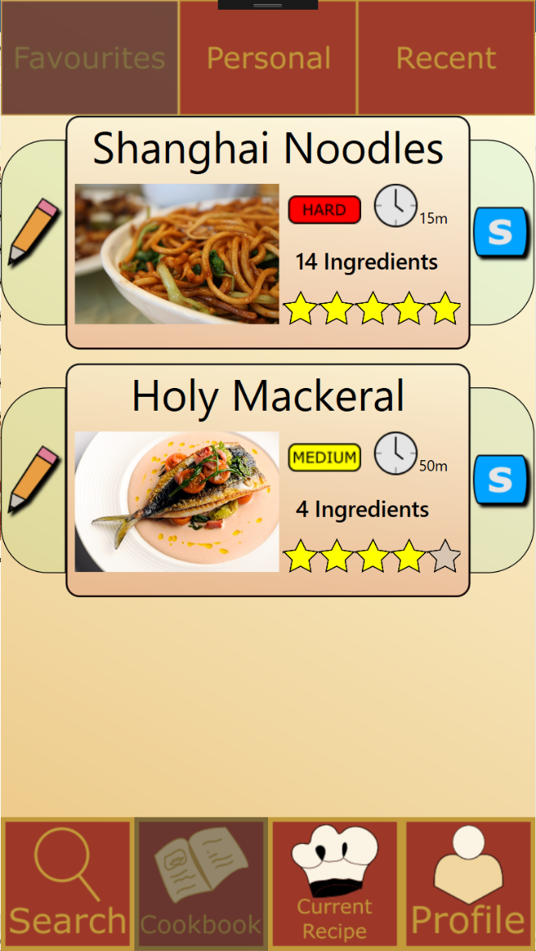

18.) Cookbook Favourite Page

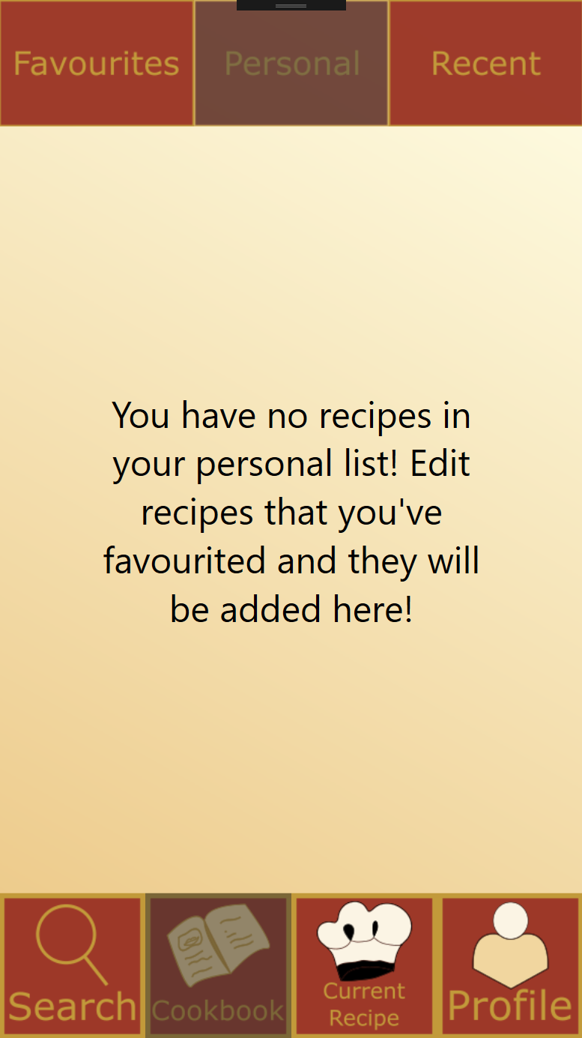

19.) Cookbook Personal Page

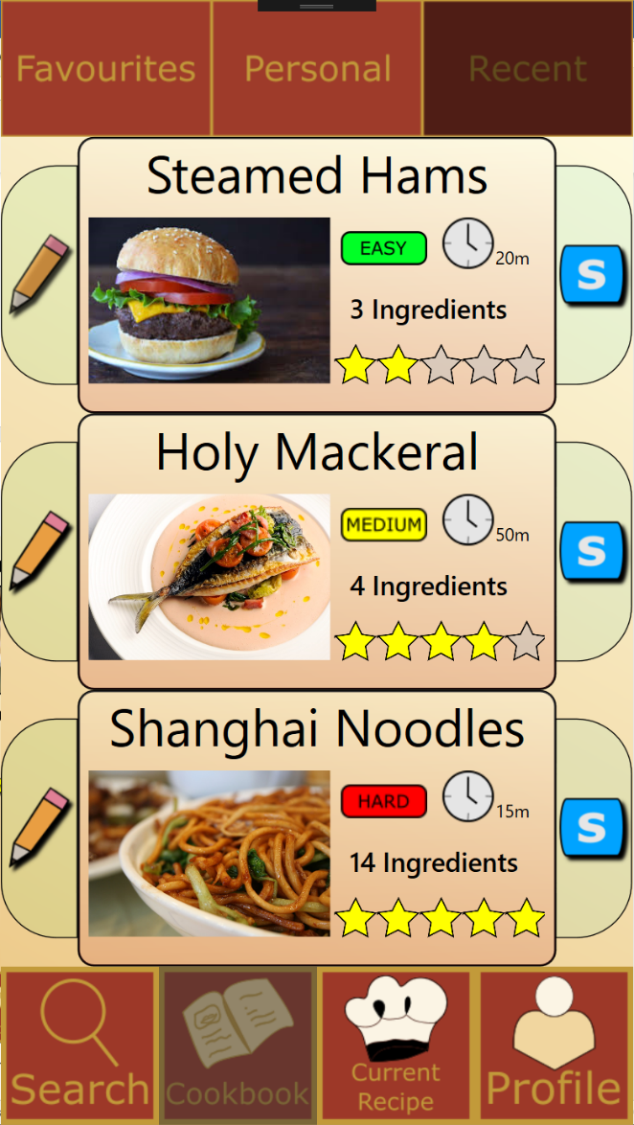

20.) Cookbook Recent Page

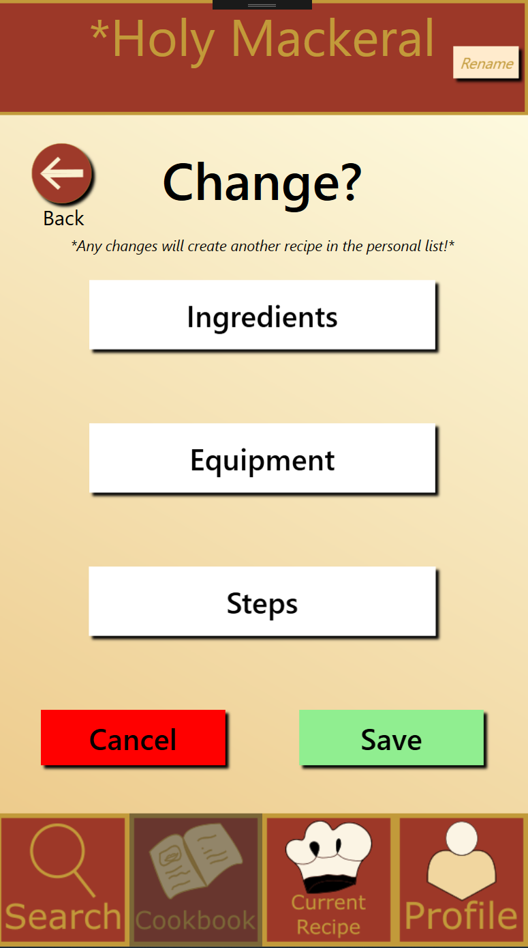

21.) Modification page

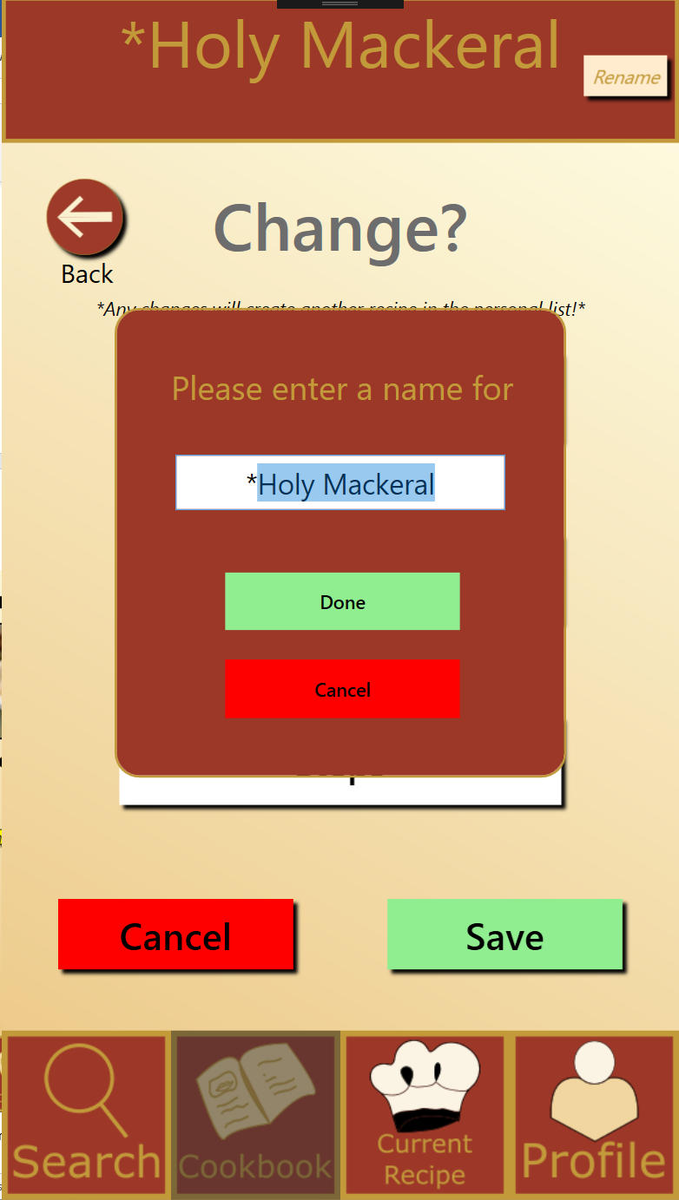

22.) Modification page, renaming

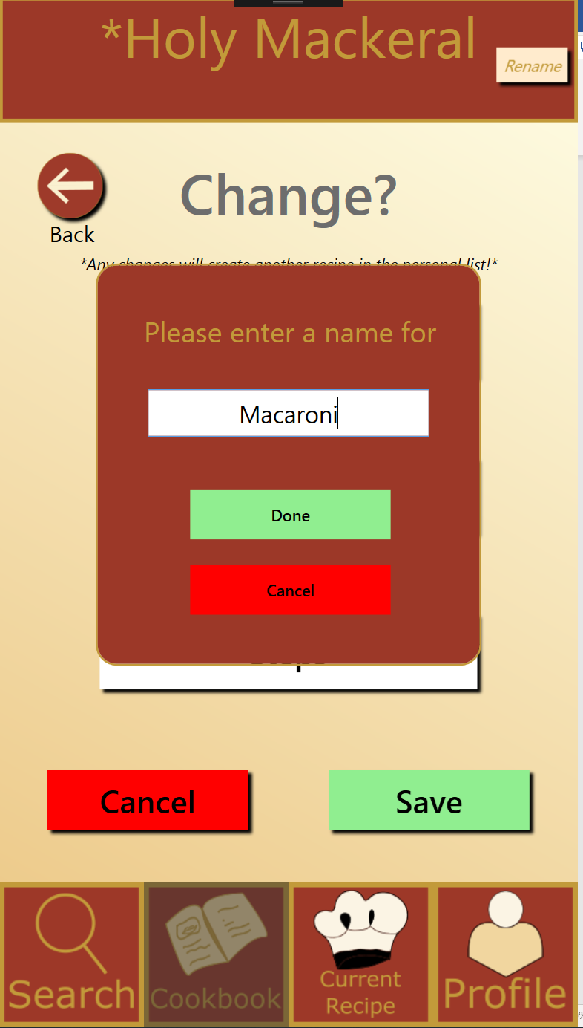

23.) Modification page, renaming cont’d

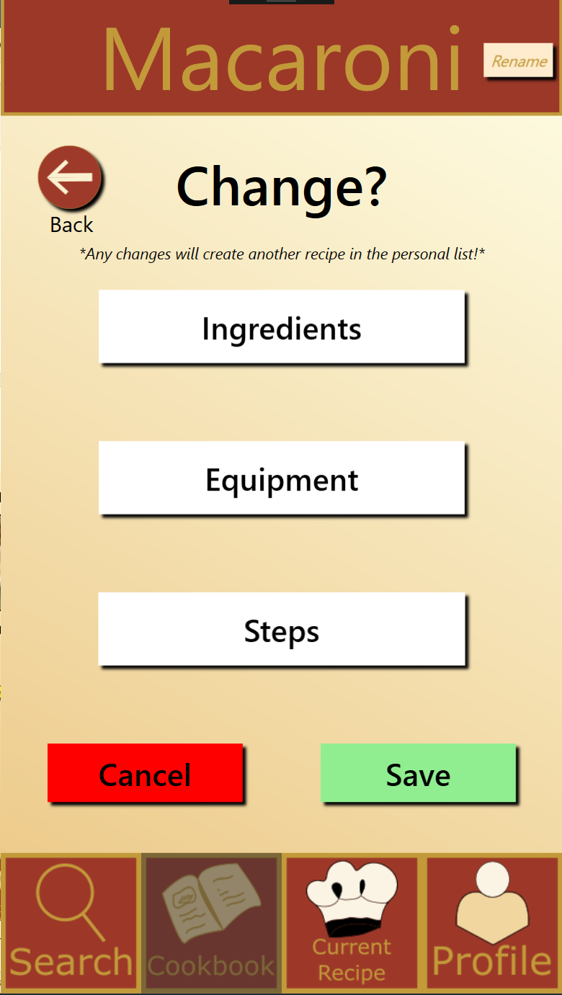

23.) Modification page, renaming cont’d

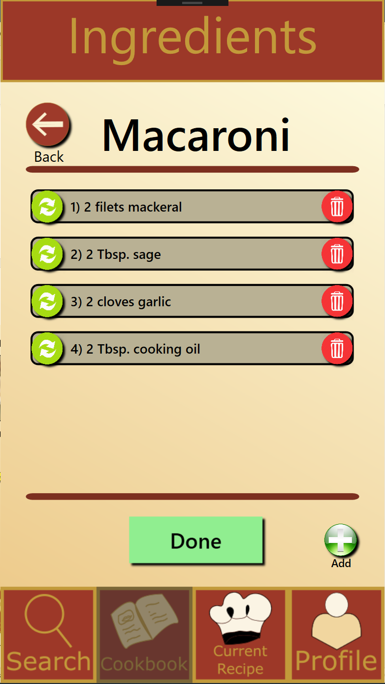

24.) Modification page, ingredients

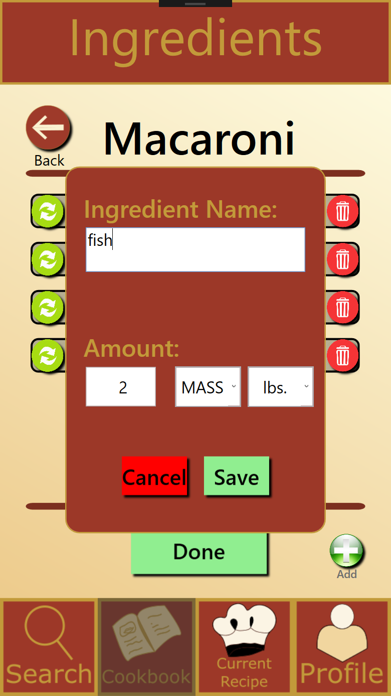

25.) Modification page, ingredients, change

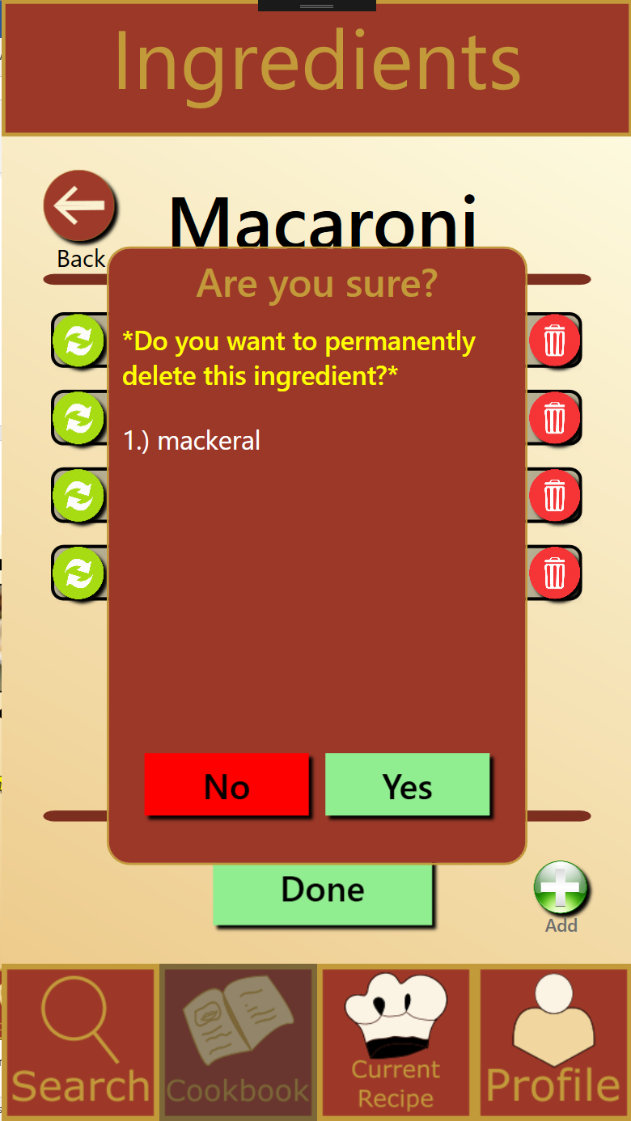

26.) Modification page, ingredients, delete

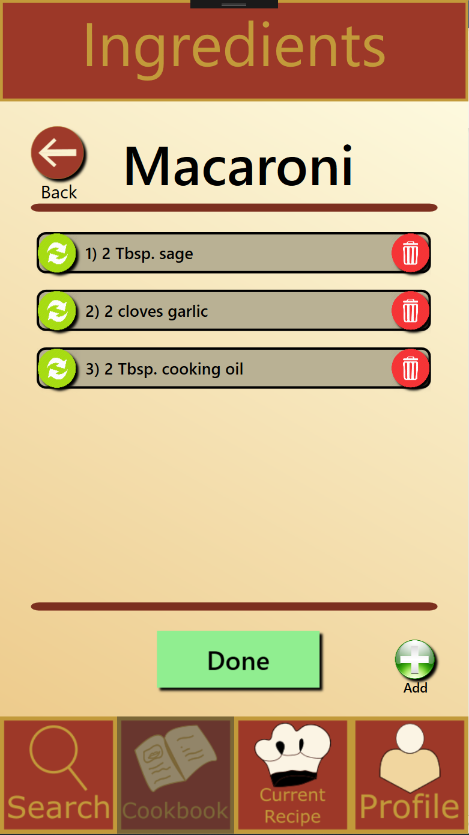

27.) Modification page, ingredients delete cont’d

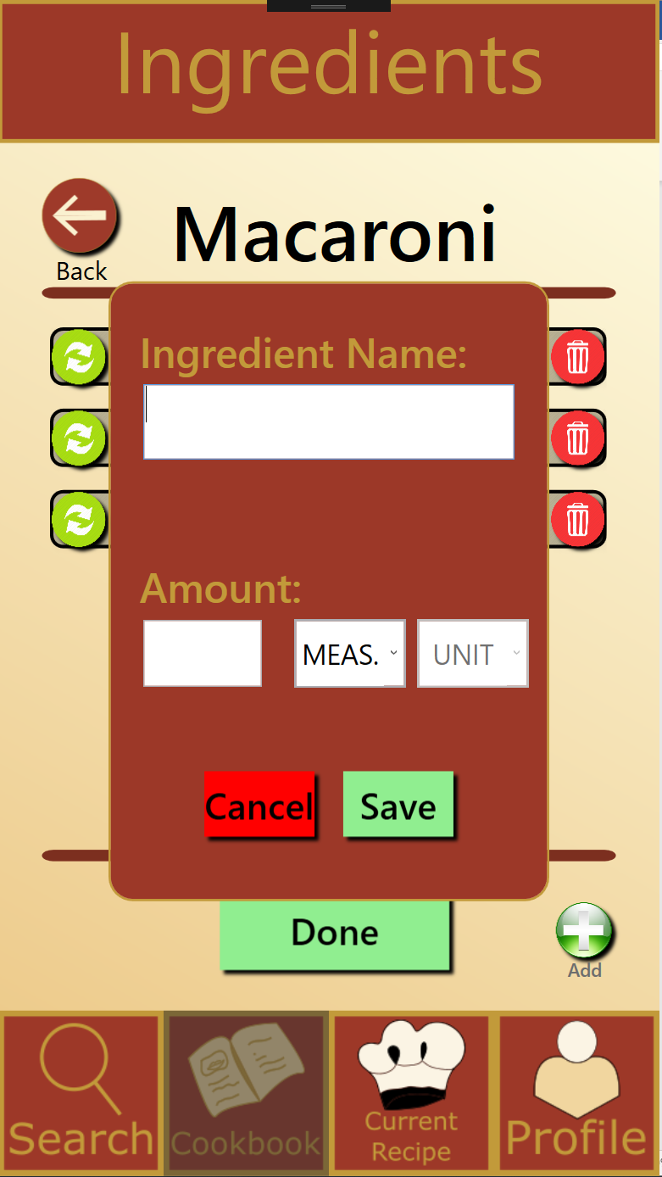

28.) Modification page, ingredients, add

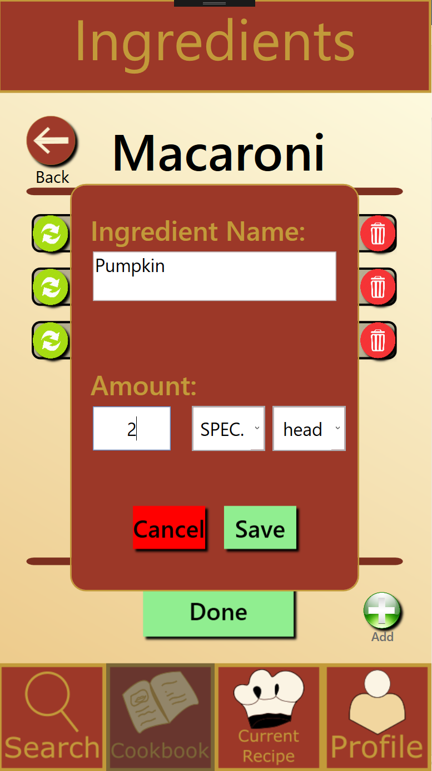

29.) Modification page, ingredients add, cont’d

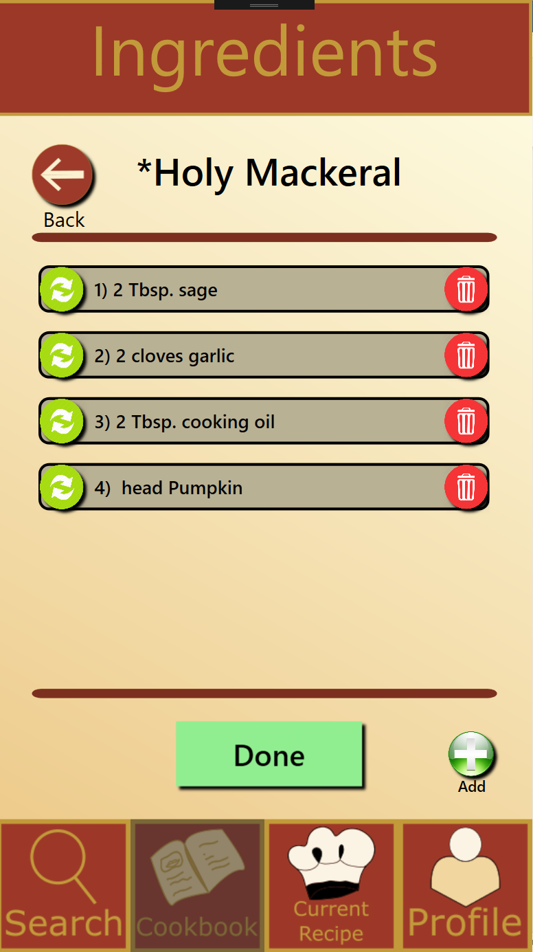

30.) Modification page ingredients add cont’d

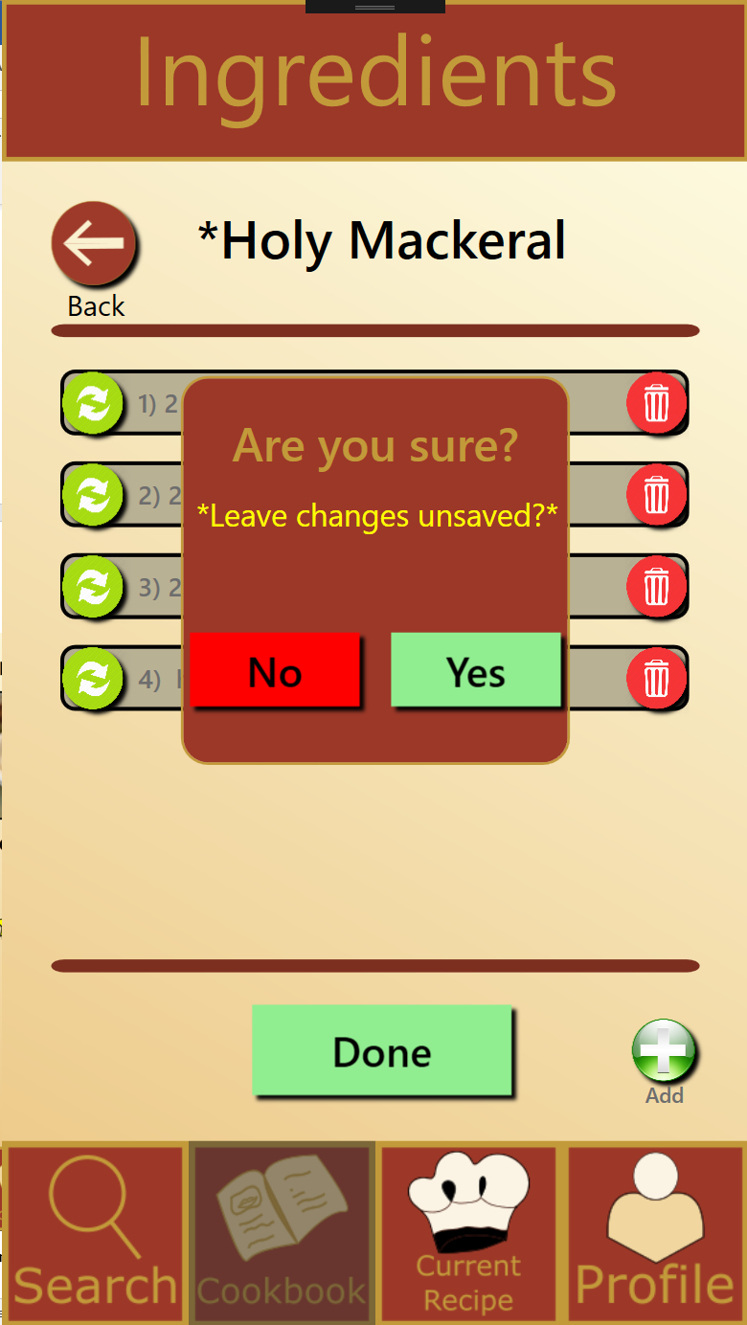

31.) Modification page, ingredients back button

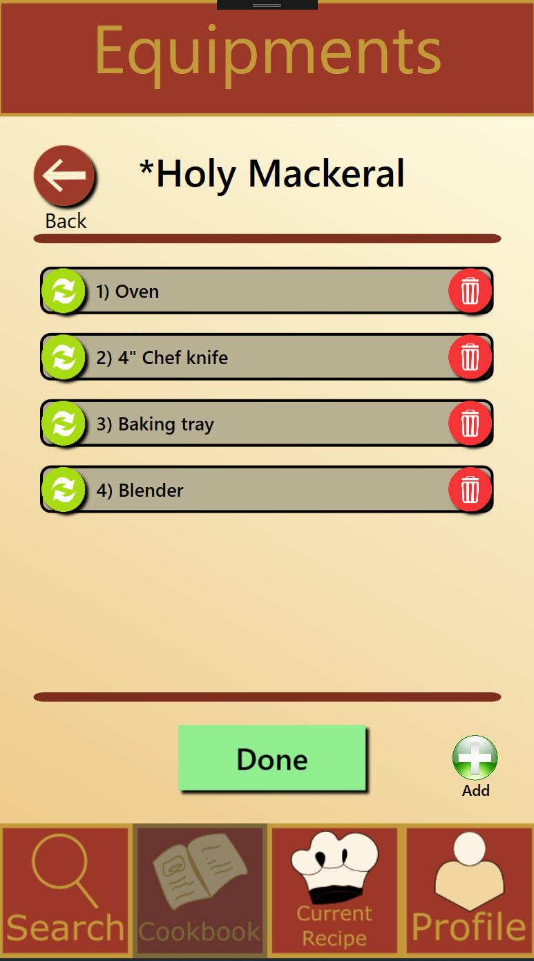

32.) Modification page, equipment

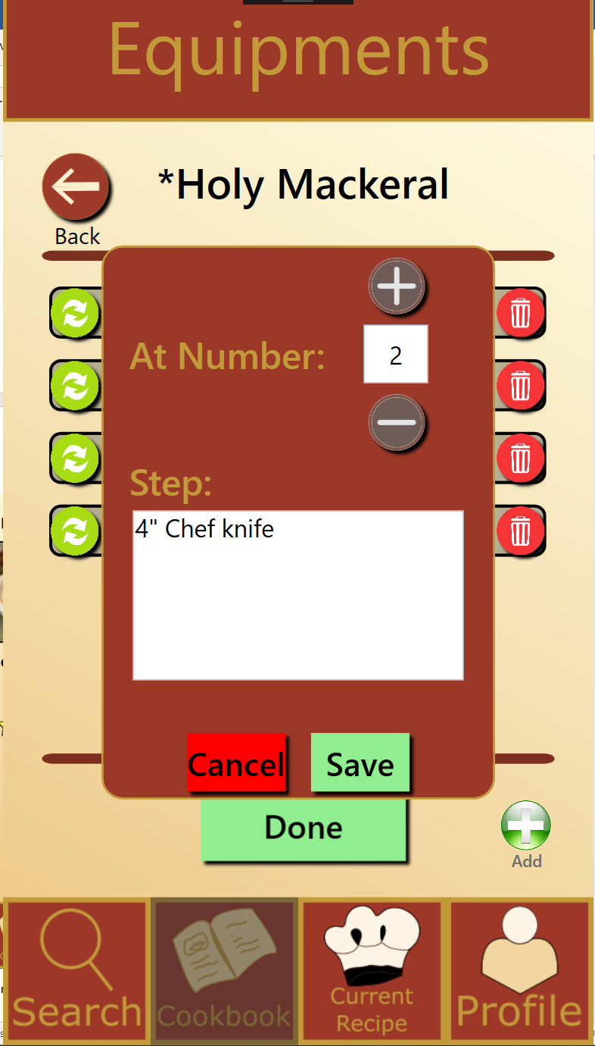

33.) Modification page, equipment change

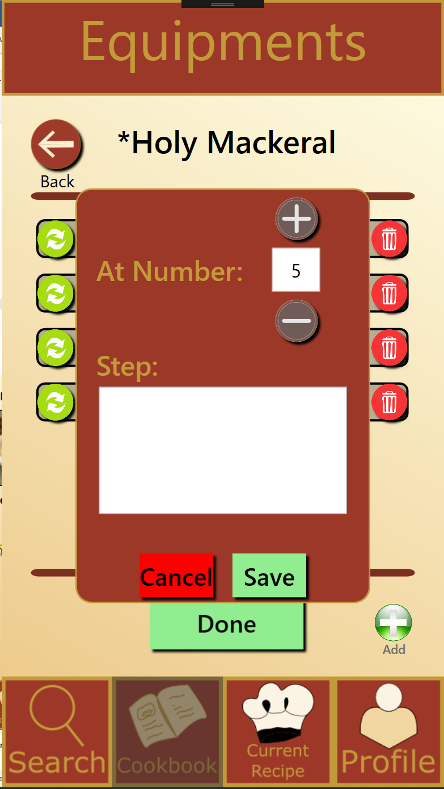

34.) Modification page, equipment, add

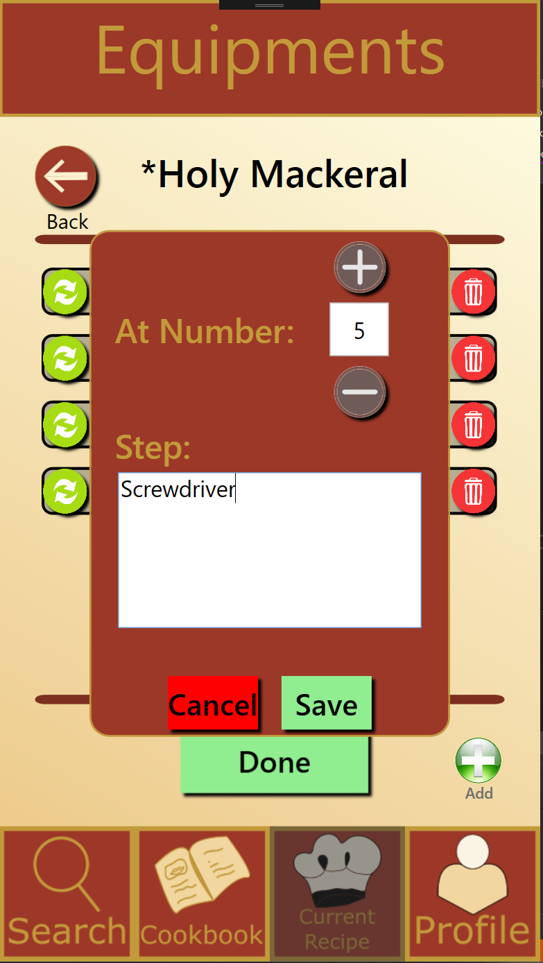

35.) Modification page, equipment, add, cont’d

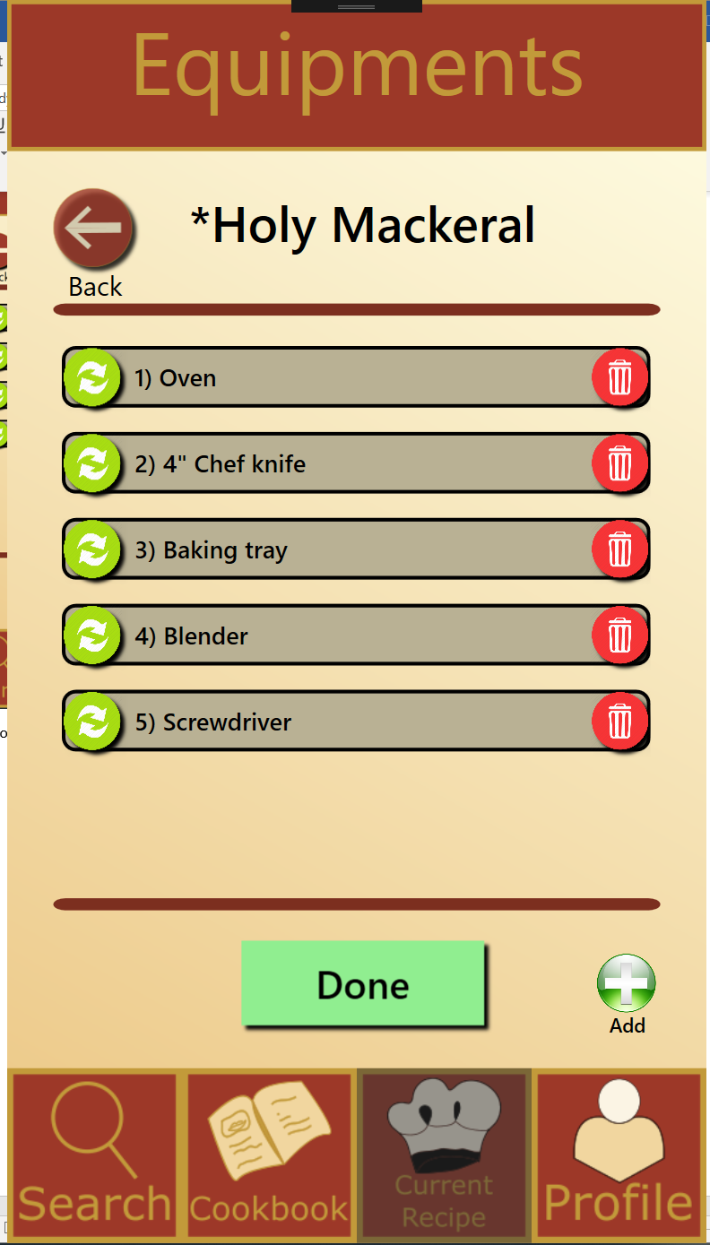

36.) Modification page, equipment, add, cont’d

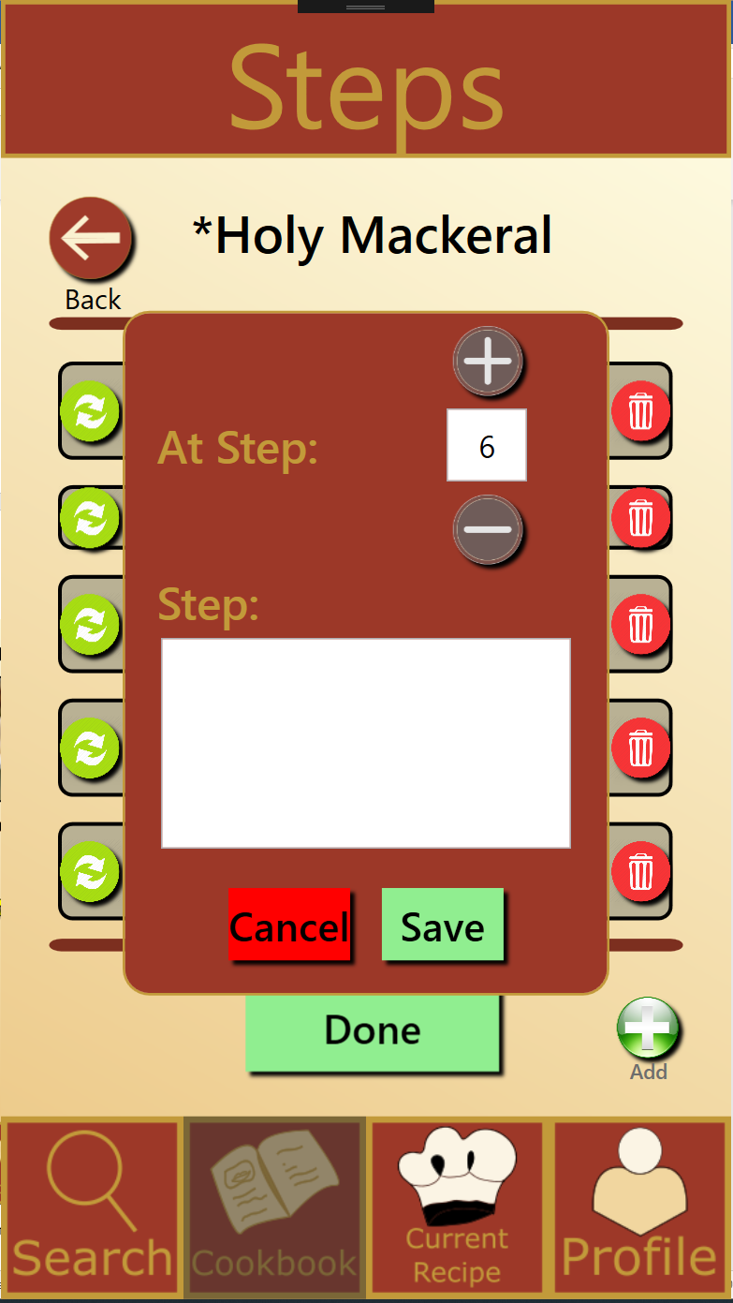

37.) Modification page, steps, add, (similar)

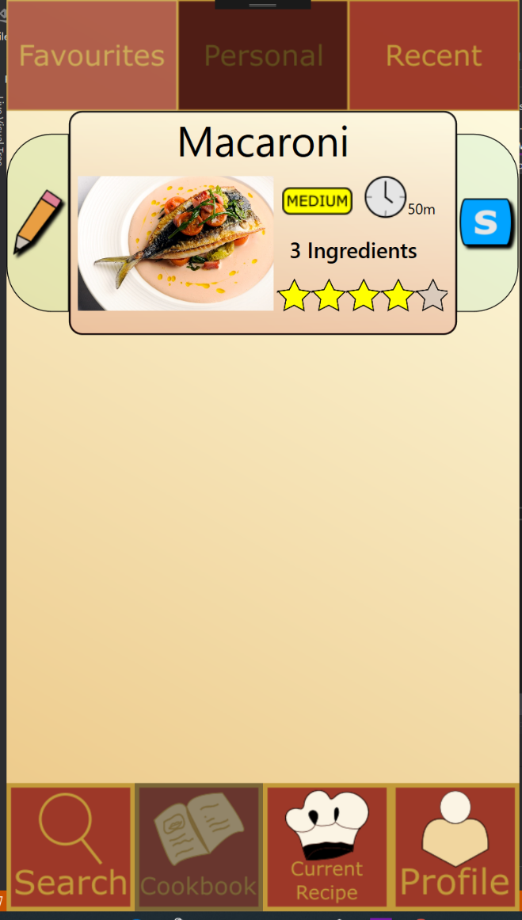

38.) Cookbook, Personal tab, Modified recipes

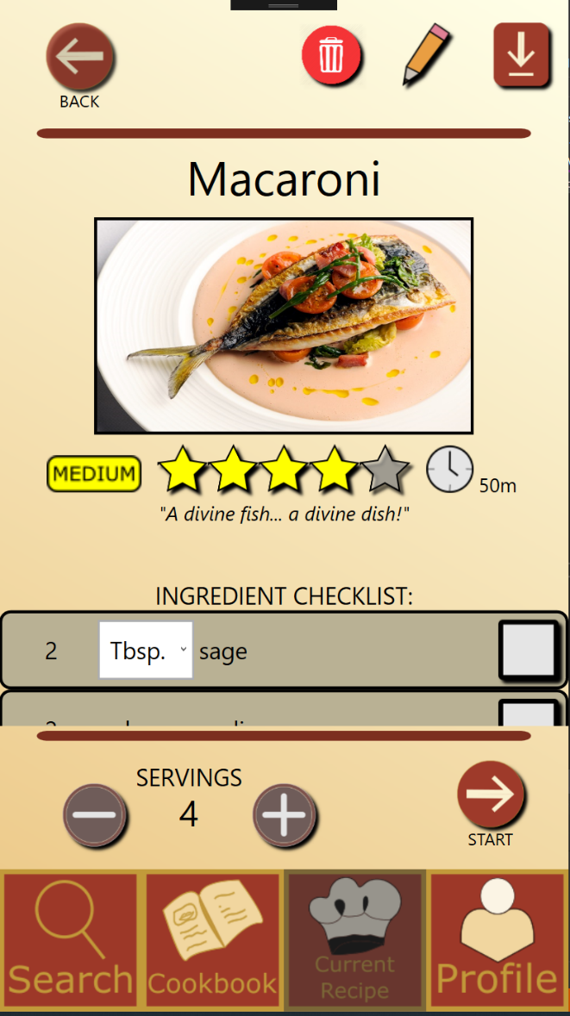

39.) Modified recipe page

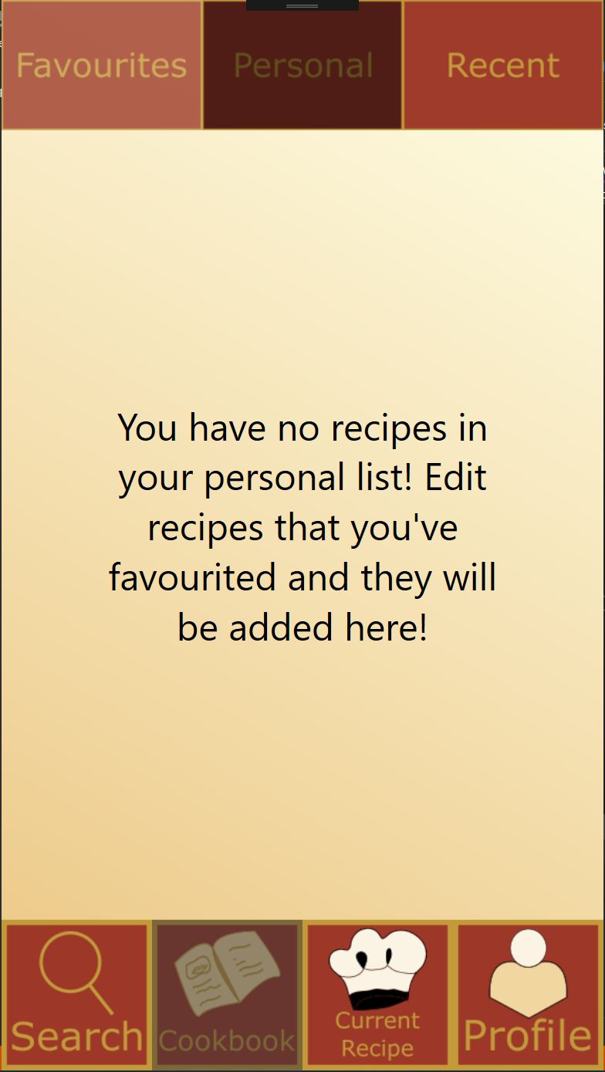

40.) Delete button on modified recipe page

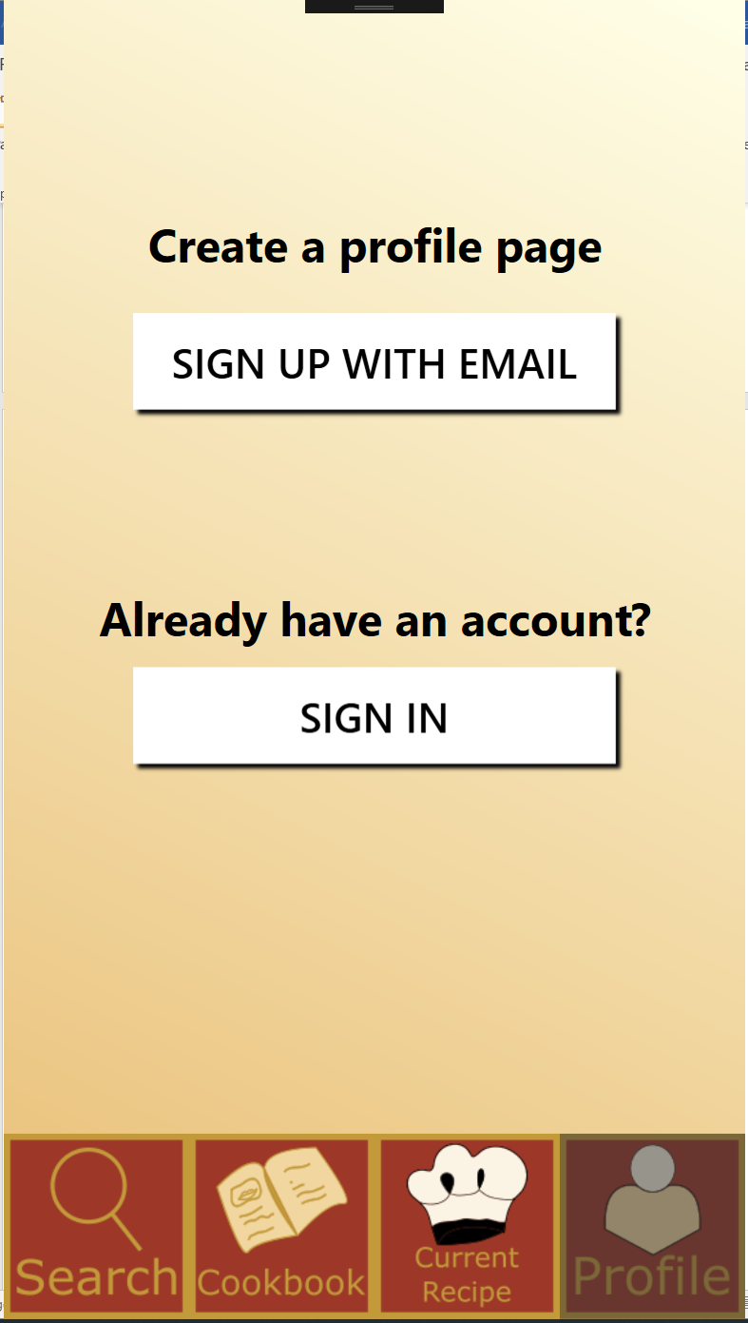

41.) Recipe Profile Page

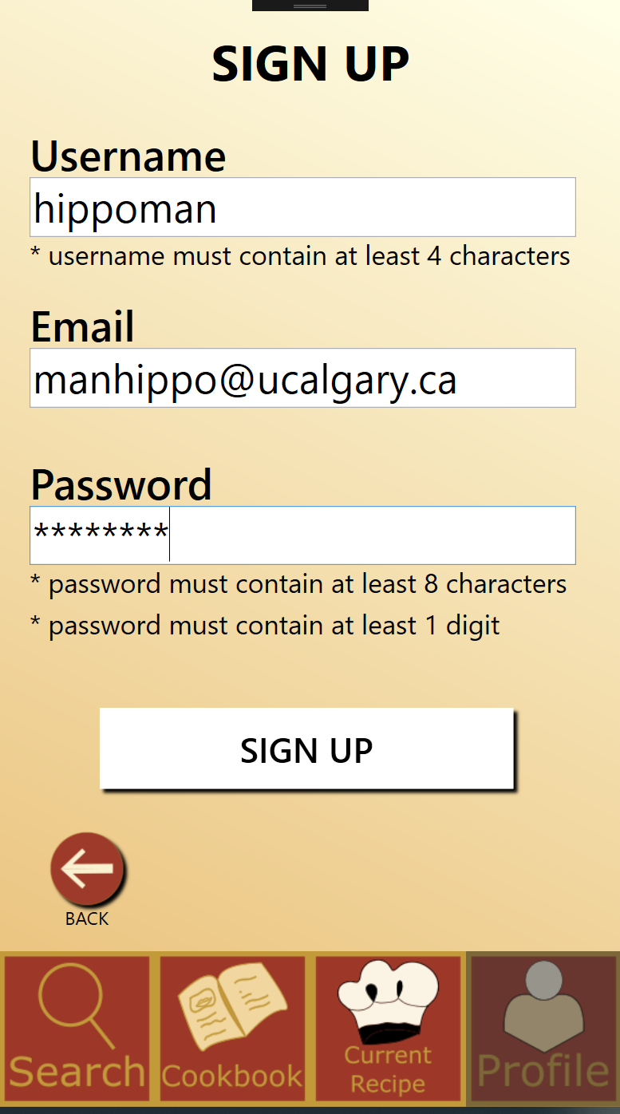  
42.) Recipe Profile Page, sign up

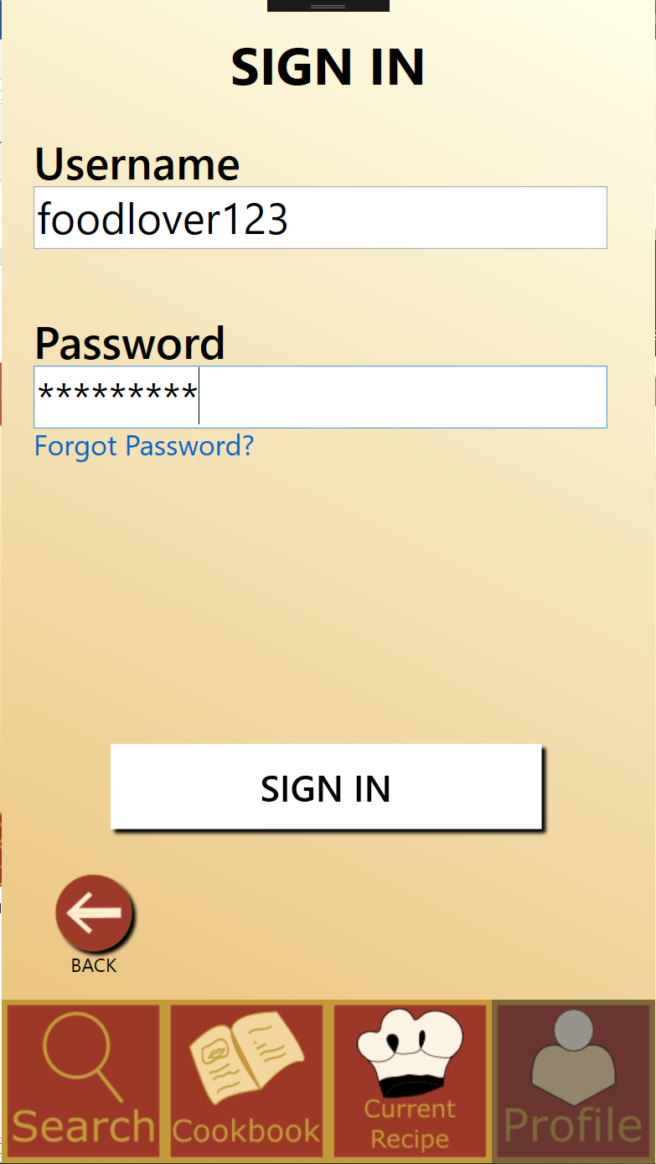

43.) Recipe Profile Page, sign in

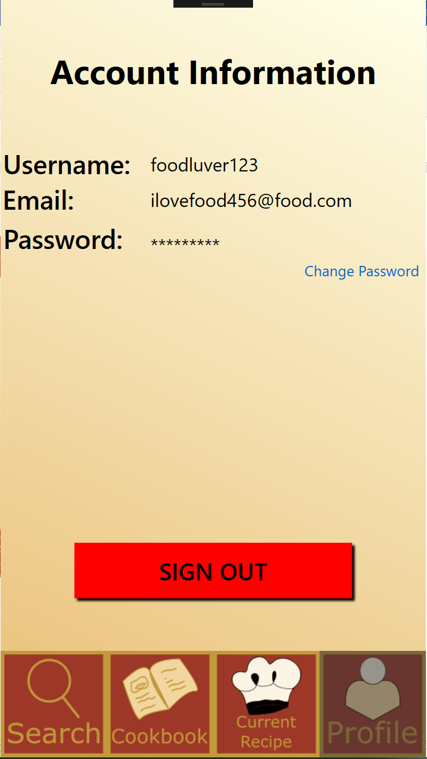

44.) Recipe Profile Page, logged in

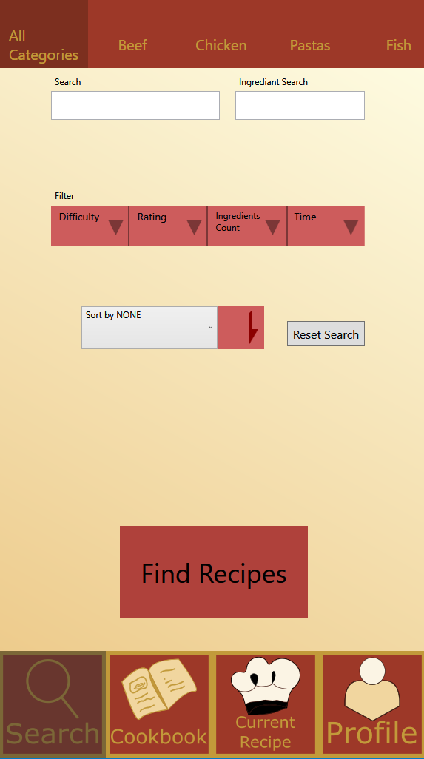

45.) Search Page

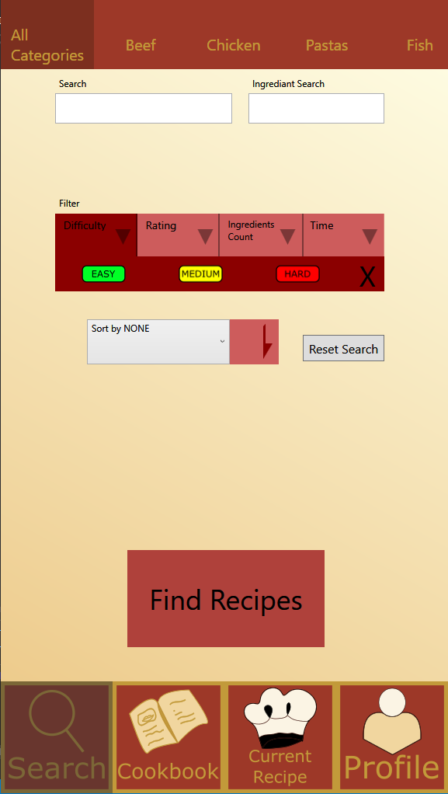

46.) Search Page (difficulty filter)

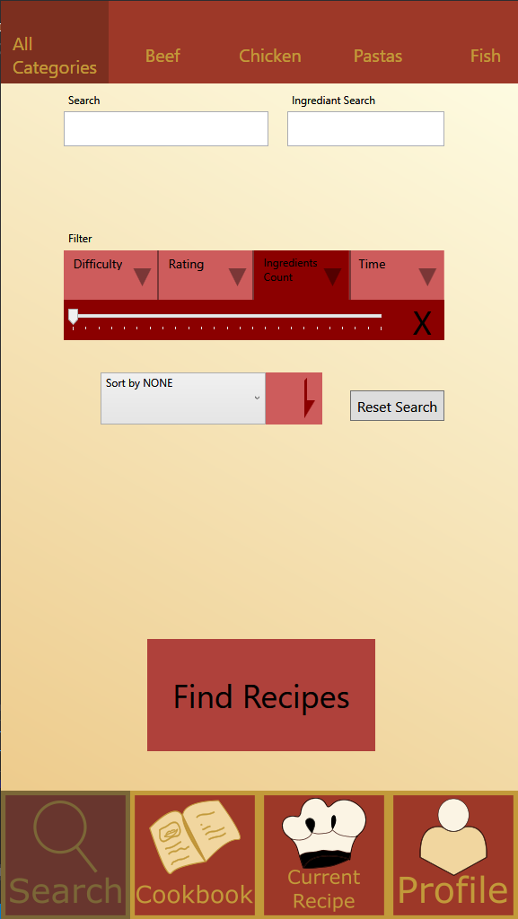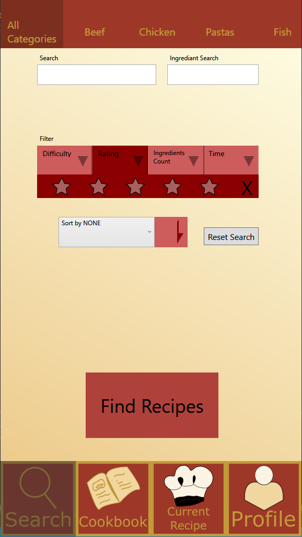

47/48.) Search Page (Rating filter)/(ingredient count filter)

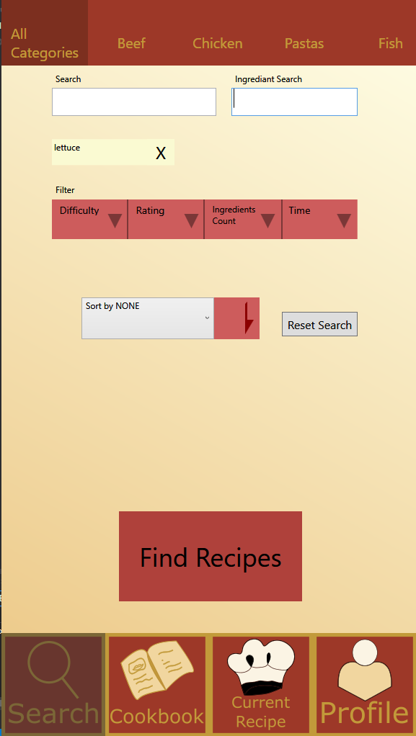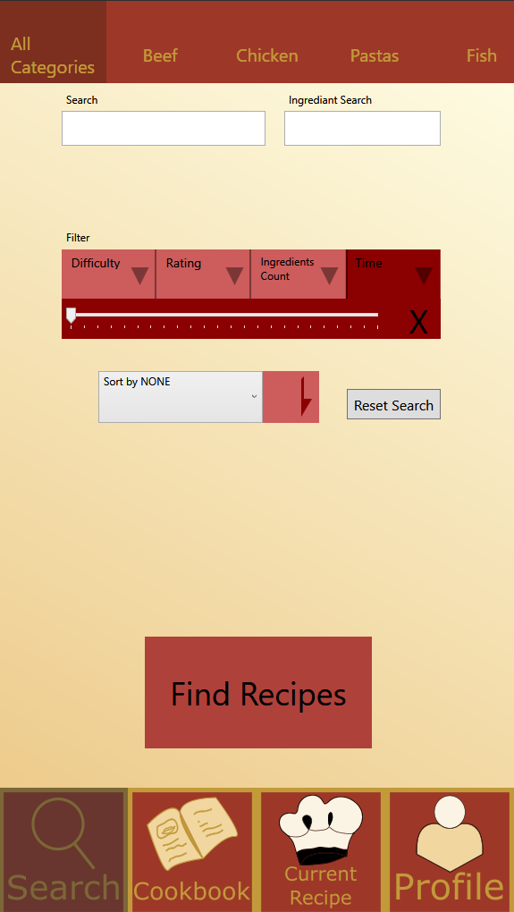

49./50.) Search Page (Duration filter)/ ingredient search

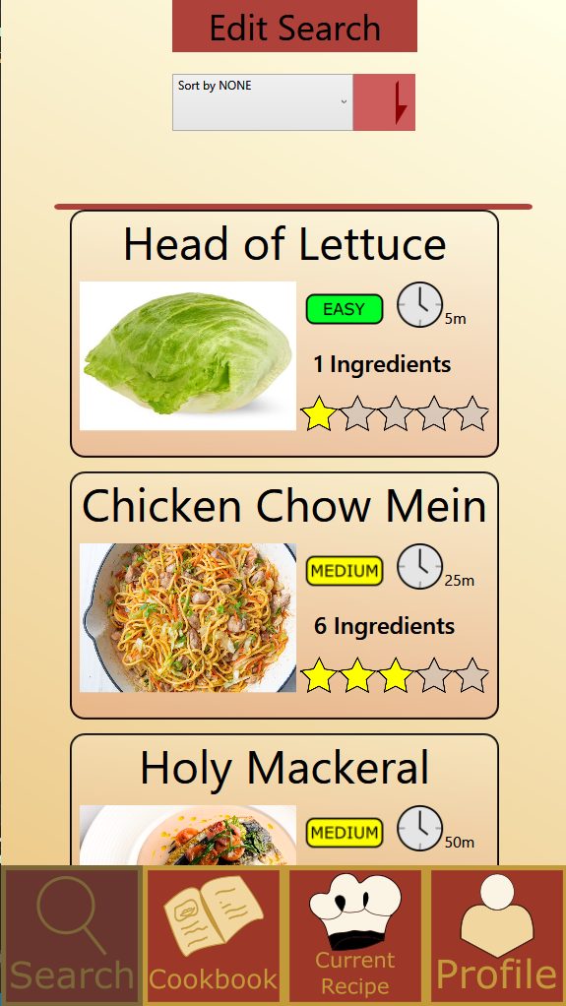

51.) Search Results Page